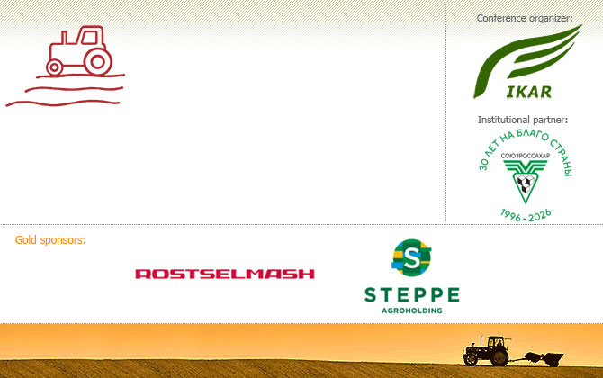
Where the Margin Is
Summer International Conference
for agricultural producers
and suppliers of agricultural
inputs and services

July 23-24, 2026
Radisson Collection Hotel, Moscow
ikar.ru/wherethemarginis

"Margin calls!"
May 5, 2026
Dear colleagues,
The early bird registration to our 4-th International Summer agricultural conference Where the Margin Is is ongoing. We thaqnk those numerous participants who have already registered for the event.

The Conference will be held on July 23-24 in legendary Radisson Collection Hotel, Moscow.
Unlike our 2-days winter conferences, the Summer conference will be of one working day (although in the evening of July 23 we hold a traditional buffet with famous Radisson Collection cuisine and live music). During the working program of July 24 we focus on crops size forecasts and prices in Russia and abroad, key ag markets S&D around the world, trade strategies, logistics and market infrastructure update.
New Summer event speaker:
Cem Bogusoglu, Sales director, Prograin, Member of BoD, Global Pulse Confederation
Past year the Conference attracted off-line participation of about 300 business owners, highly ranking executives and analysts from leading domestic, Azerbaijan, Belarus, China, Kazakhstan, UAE, Uzbekistan agribusiness companies. On-line participatyion is aLso possible. Please see the archive of previous Conferences.
If you have any questions, or suggestions, please don’t hesitate to ask us at: www@ikar.ru and d.rylko@ikar.ru

Annual Conference Agribusiness «Where the Margin Is» © 2009-2026 IKAR, тел: +7 (495) 232-90-07

